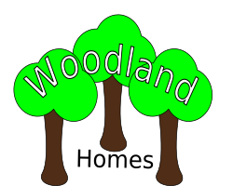

The Spinney
Greenlands
Foreston
Barkshire
FF2 9OF
0115-496 0377

<Insert date field here. Use dd:MMMM:yyyy format>

<Insert Title and FamilyName mergefields here>
< Insert Address mergefields here – one per line>

Dear < Insert GivenName mergefield here >,
Thank you for your interest in Woodland Homes.
< Insert Conditional mergefield for text about availability here >
< Insert Conditional field for closing text here >

Regards,
< Insert Candidate name, Centre number, candidate number here >

